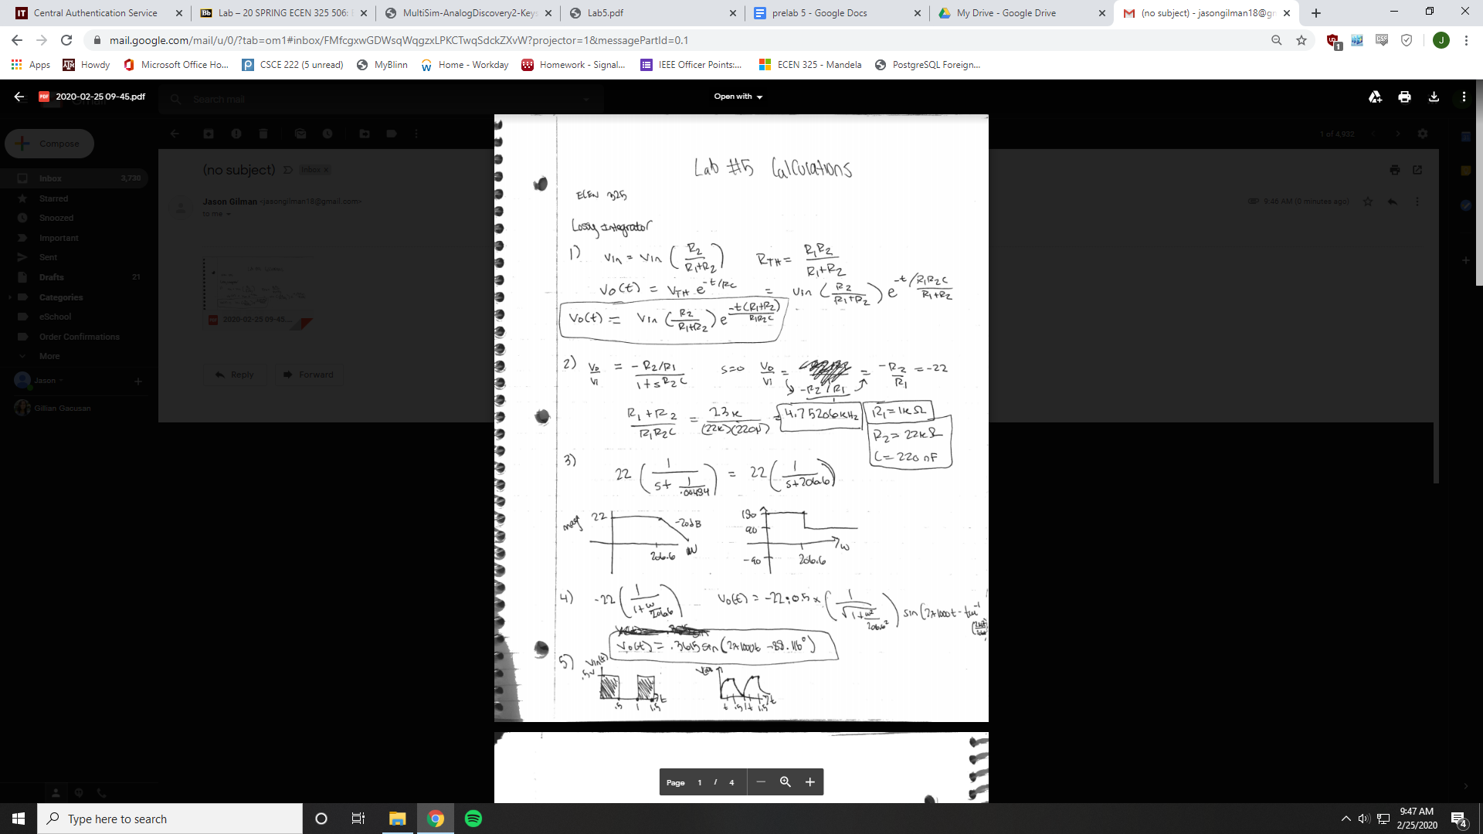

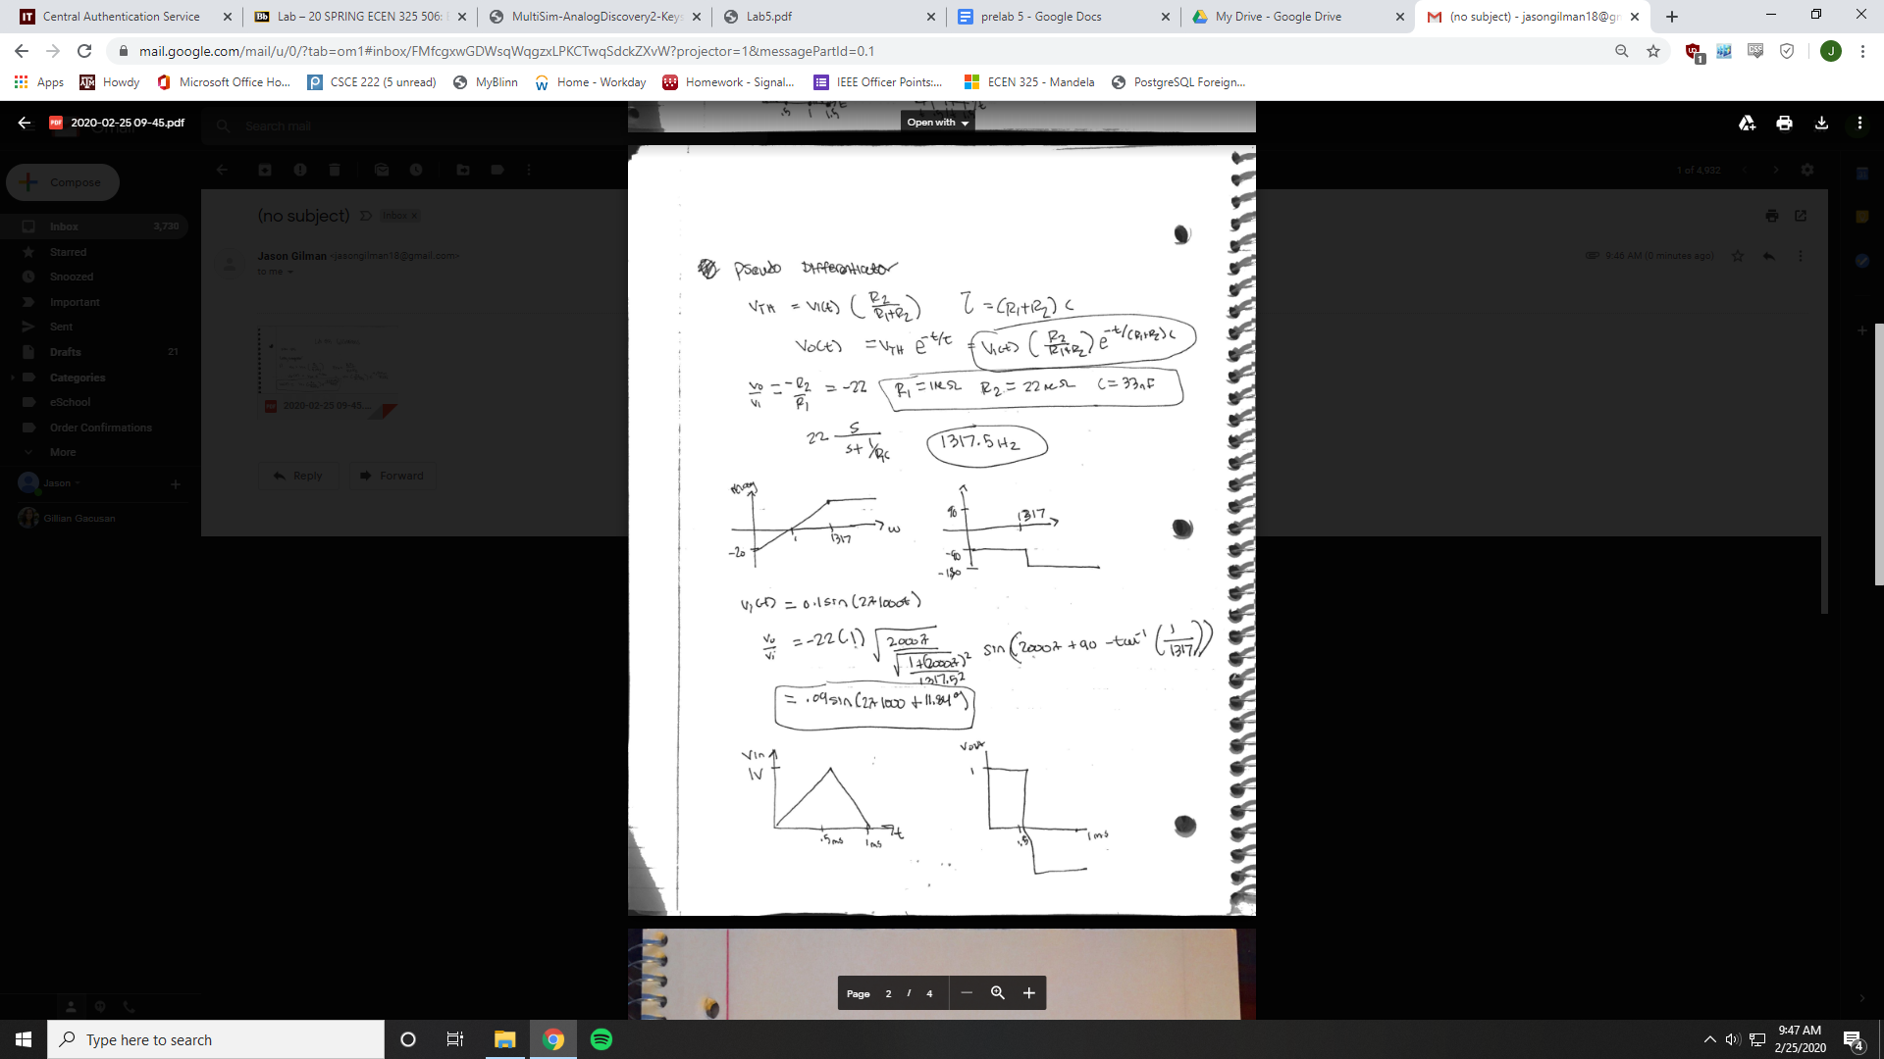

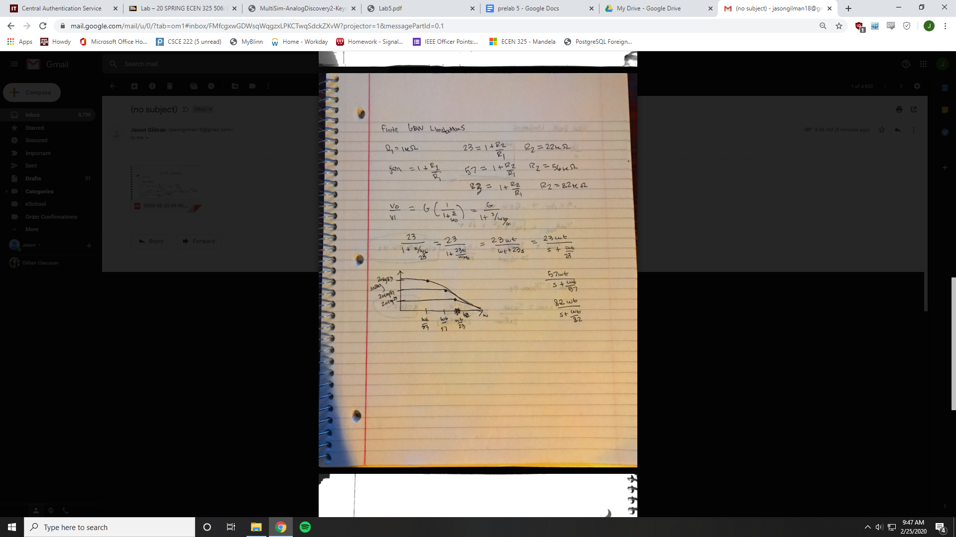

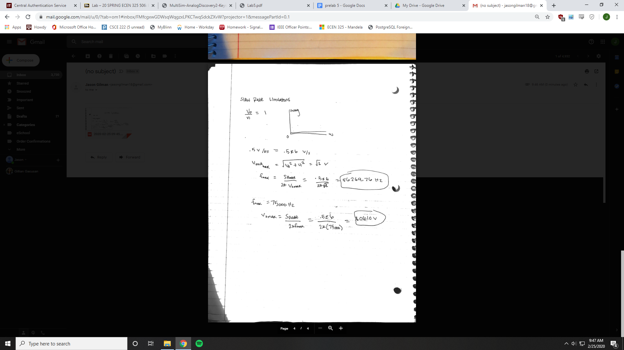

Simulations

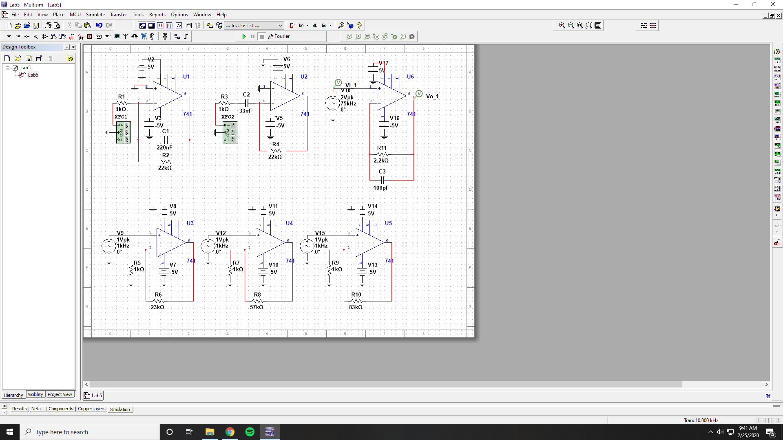

Lossy Integrator Bode Simulation

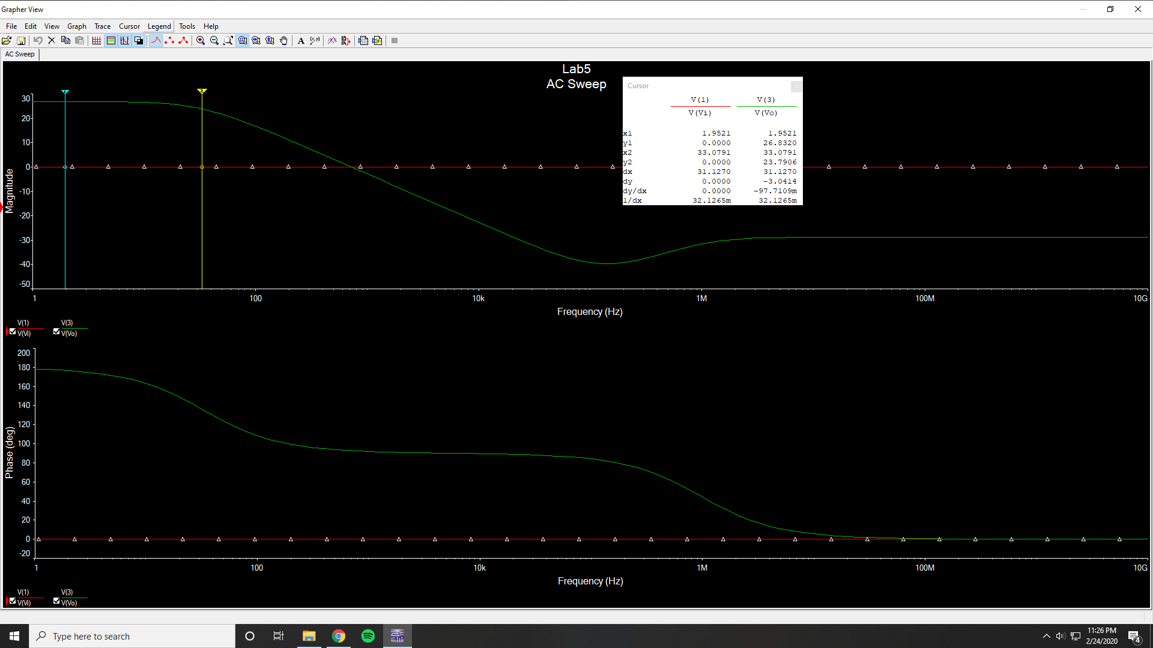

Low frequency gain = 26.8320 dB

3 dB frequency = 33.0791 Hz

1 kHz magnitude = 26.8320 dB

1 kHz phase = 178.25 °

Lossy Integrator Time-Domain Simulation

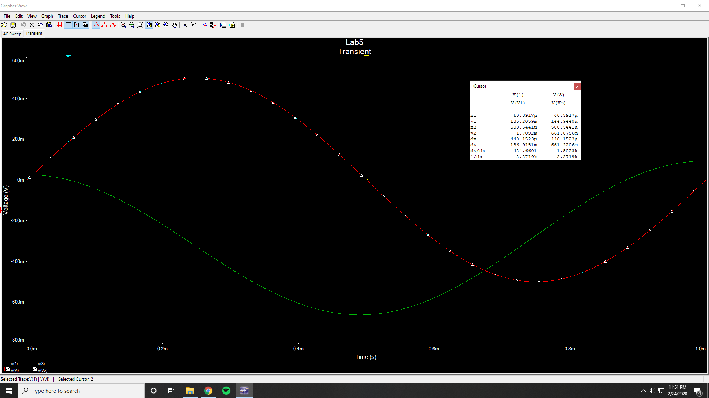

Vi Amplitude = 25.5433 mV

Vo Amplitude = 499.99 mV

Phase Difference = 158.063 °

Lossy Integrator Time-Domain Simulation (Square Wave)

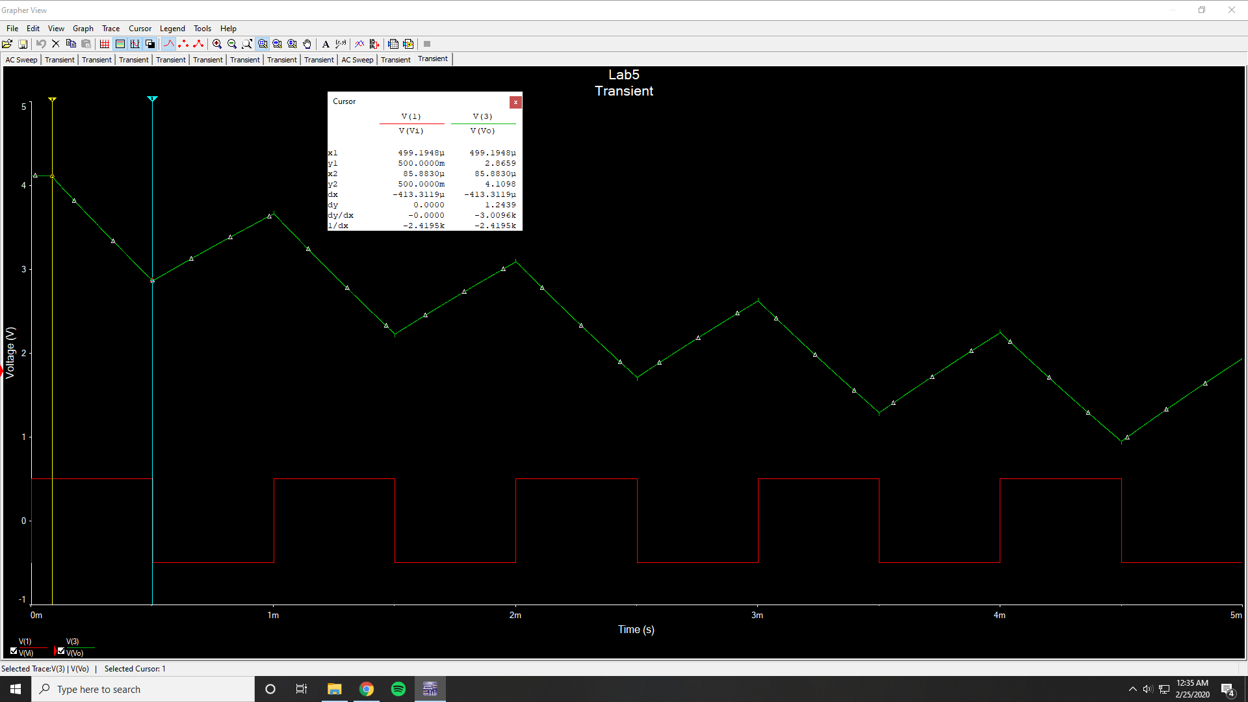

Vp2p = 1.2439 V

Pseudo Differential Bode Simulation

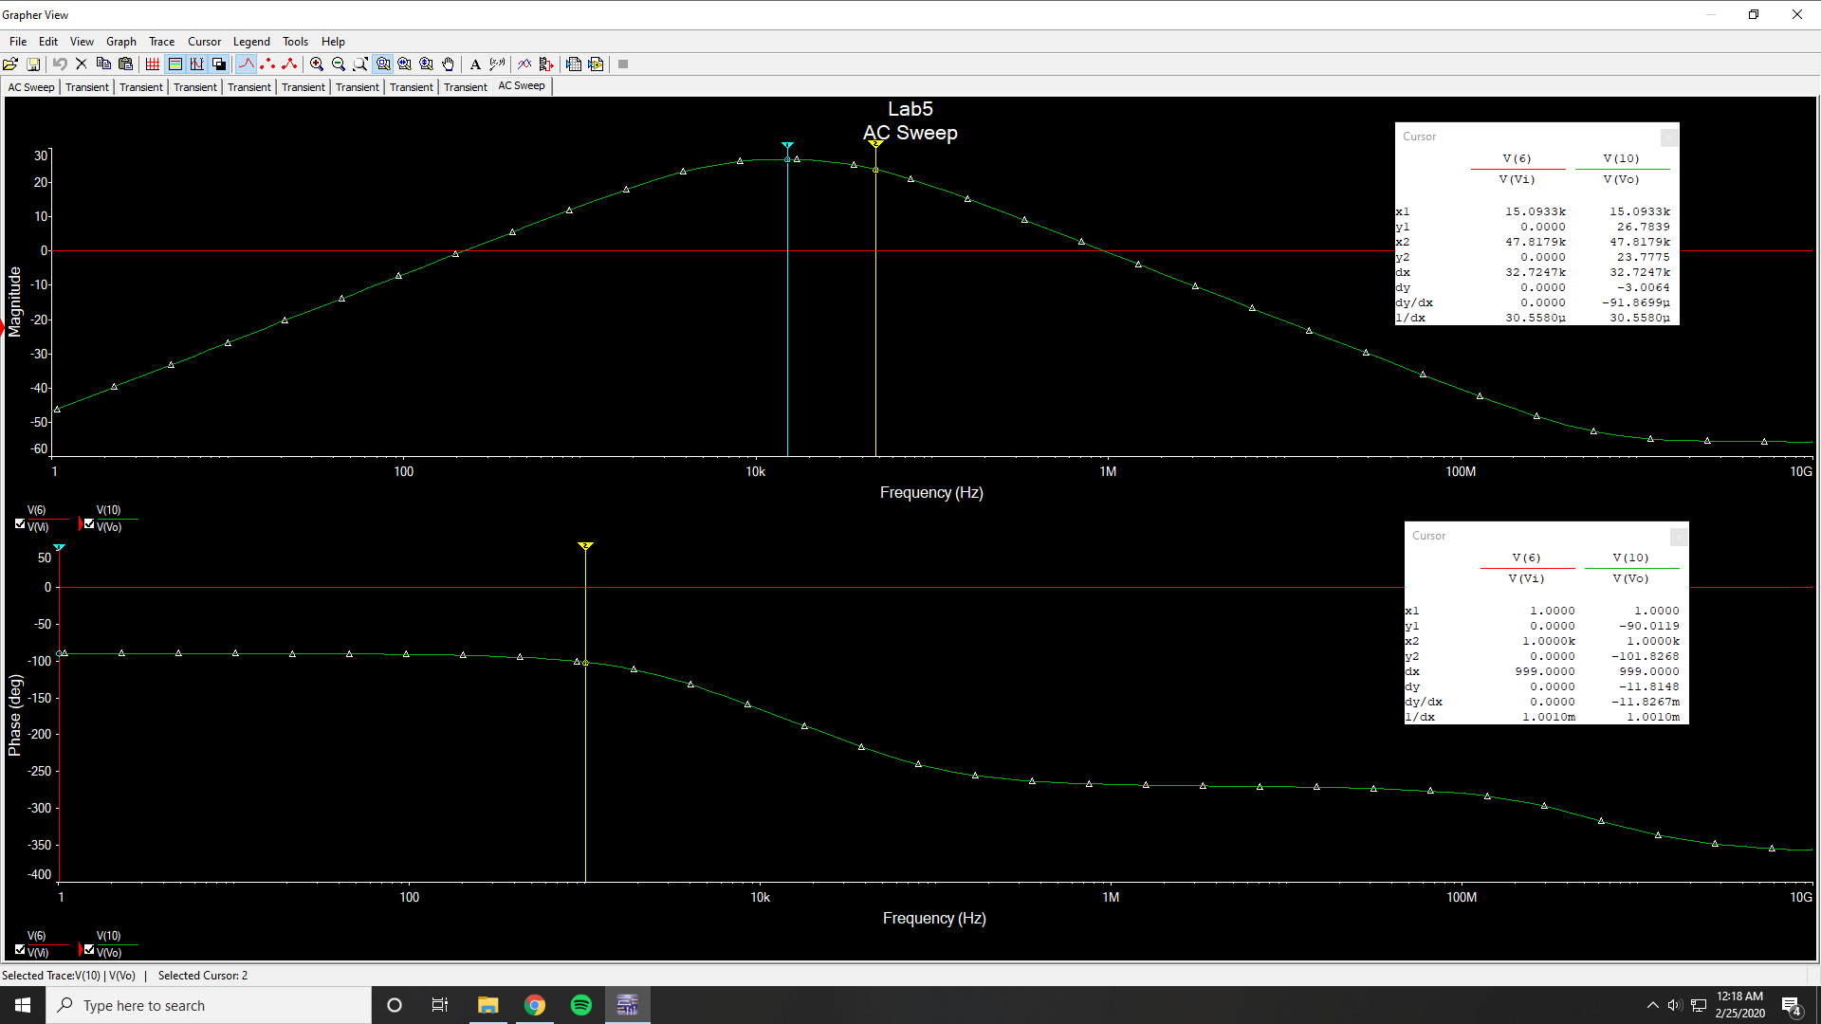

Low frequency gain = -63.0482 dB

3 dB frequency low = 4368 Hz

3 dB frequency high = 47817 Hz

1 kHz magnitude = 13.2338 dB

1 khz phase = -101.8268 °

Pseudo Differential Time-Domain Simulation

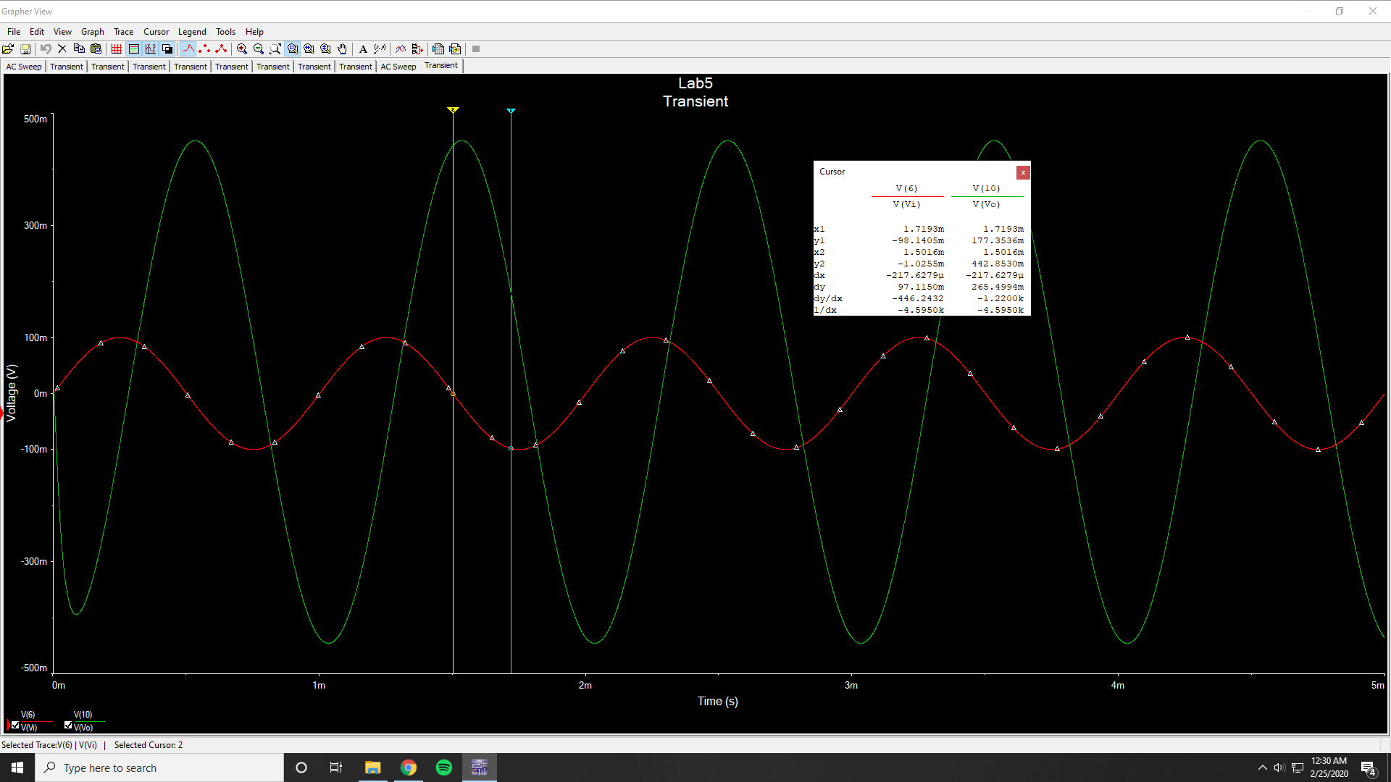

Vi Amplitude = 99.967 mV

Vo Amplitude = 451.4386 mV

Phase Difference = -79.308 °

Pseudo Differential Time-Domain Simulation (Triangular Wave)

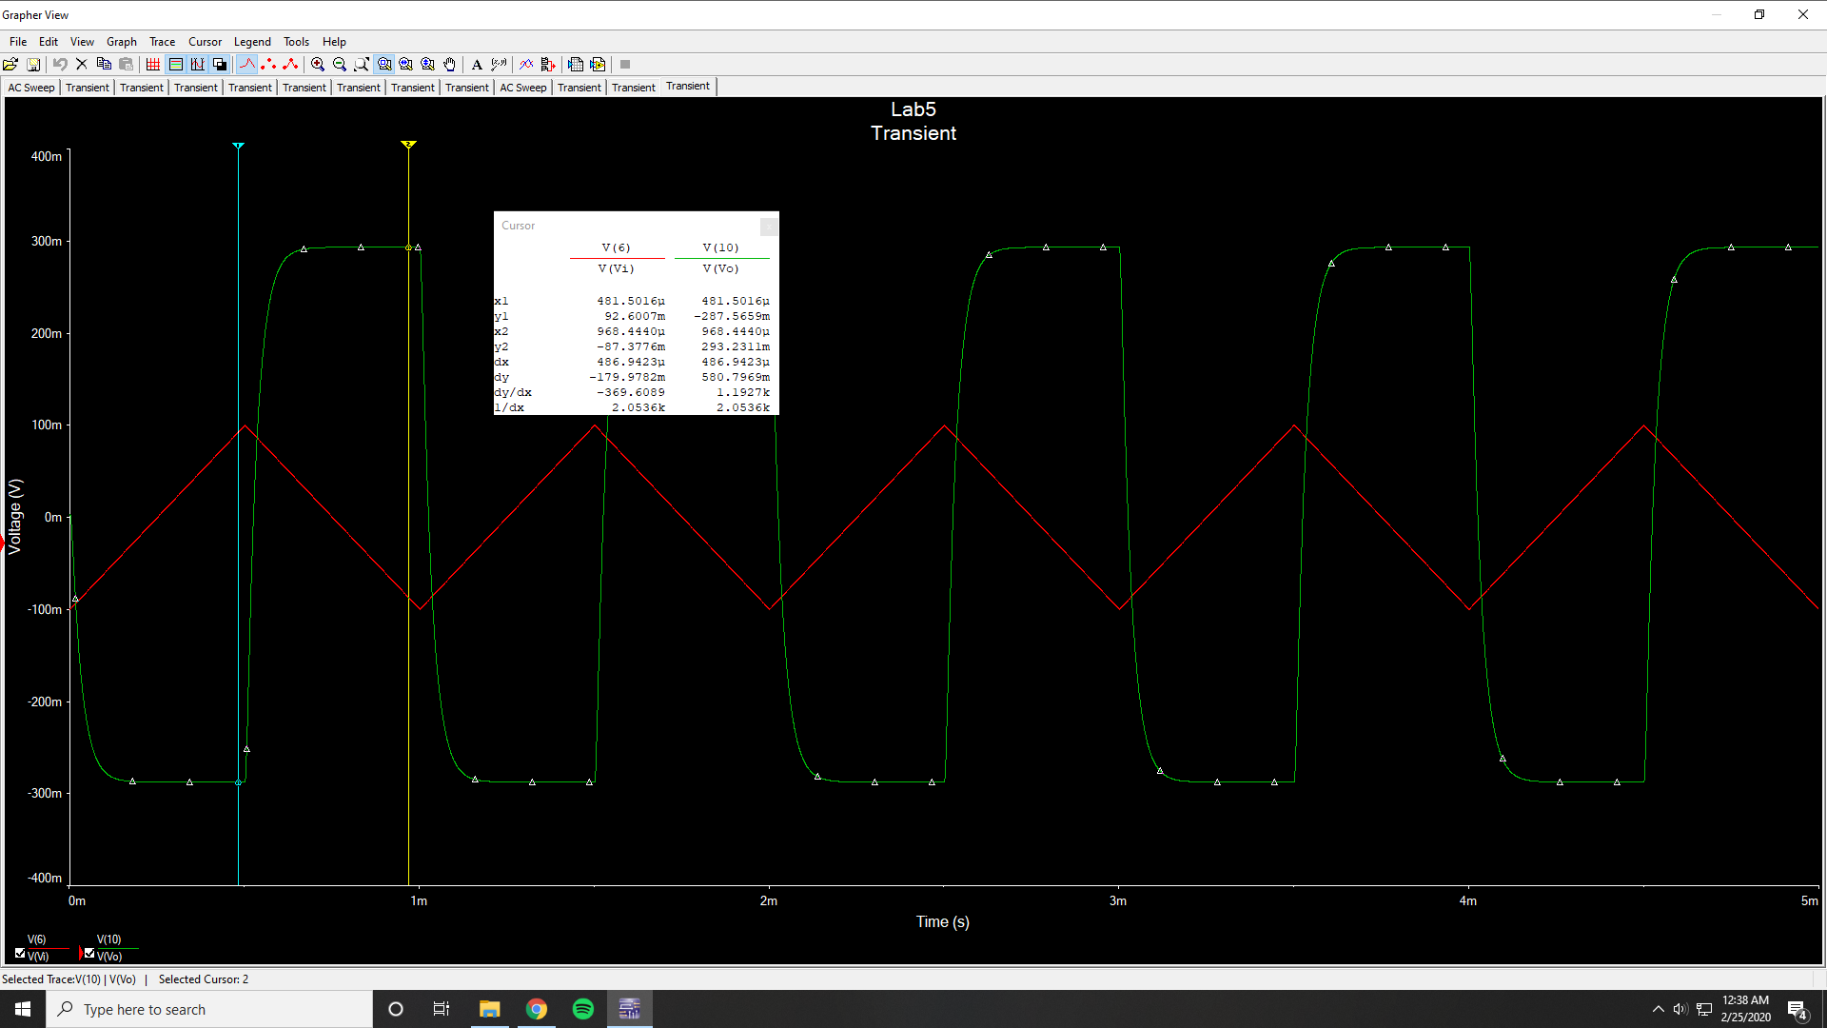

Vp2p = 580.7969 mV

Finite GBW Limitations Bode Simulation

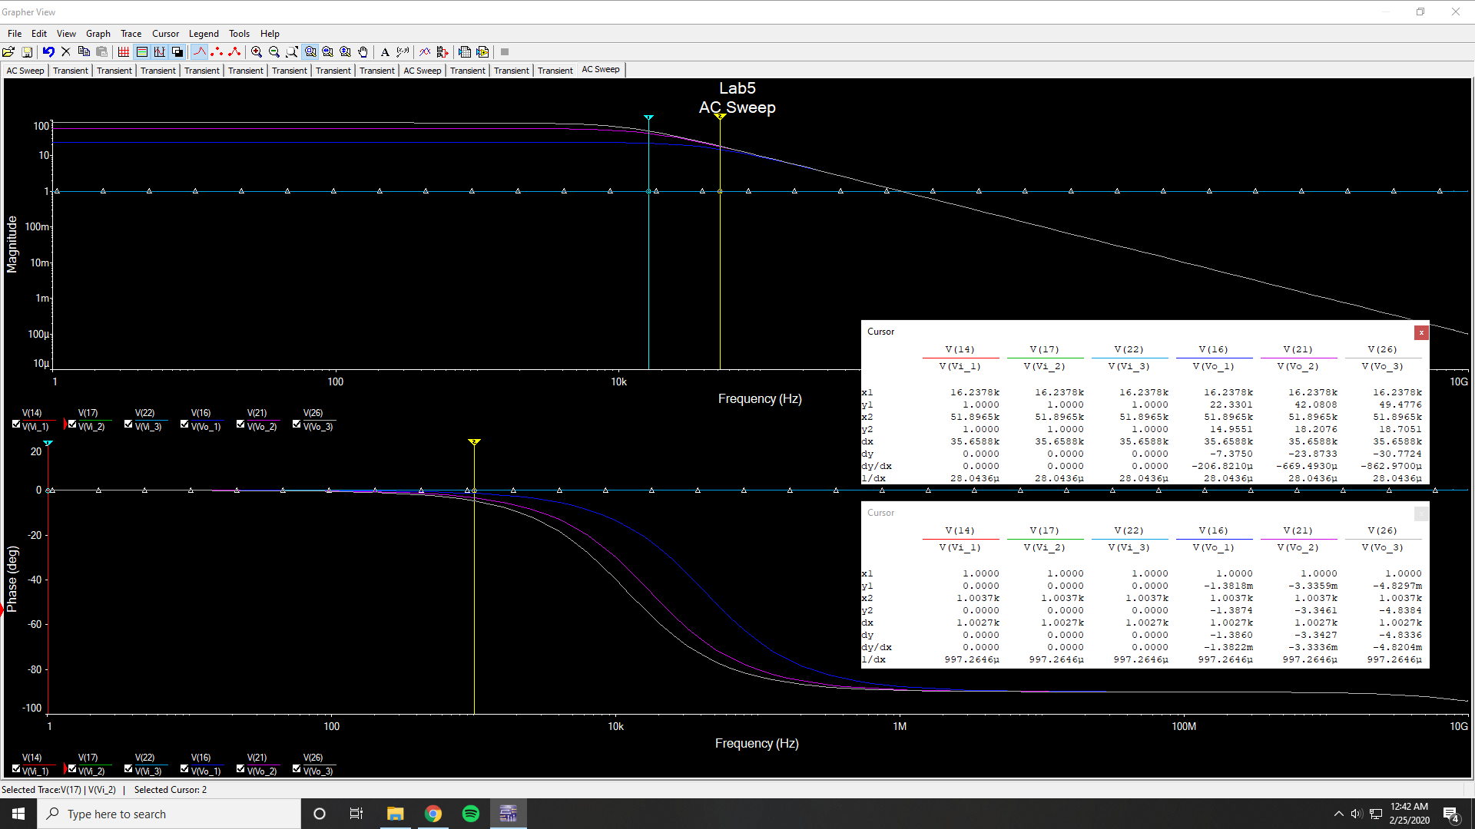

Low Frequency Gain @ 23 = 27.6029 dB

Low Frequency Gain @ 57 = 35.2658 dB

Low Frequency Gain @ 83 = 38.4817 dB

3 dB Frequency @ 23 = 41.325 kHz

3 dB Frequency @ 57 = 17.2917 kHz

3 dB Frequency @ 83 = 12.052 kHz

Slew Rate Limitations Bode Simulation

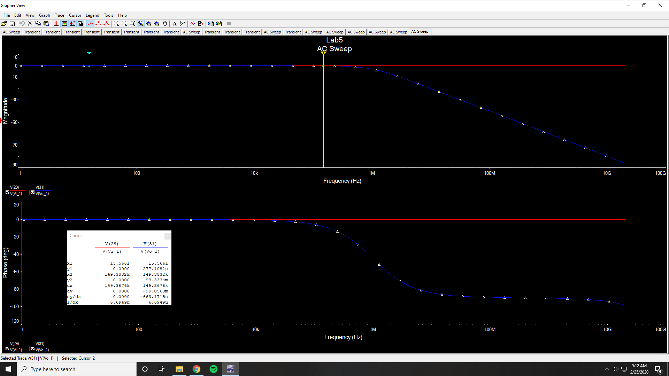

Low Frequency Gain = -277.1081 µdB

3 dB Frequency = 994.8678 kHz

75 kHz Magnitude = -25.9007 mdB

150 kHz Magnitude = -99.3334 mdB

Slew Rate Limitations Time-Domain Simulation (75 kHz 1V)

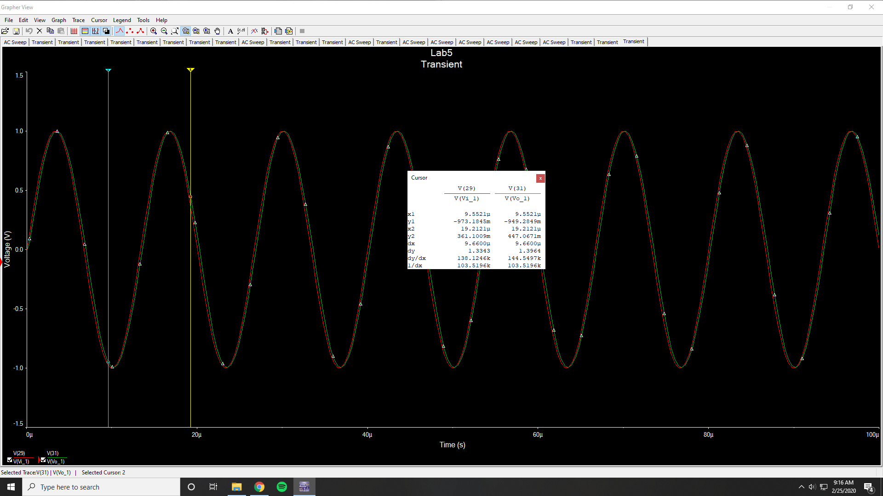

Slew Rate Limitations Fourier Simulation (75 kHz 1V)

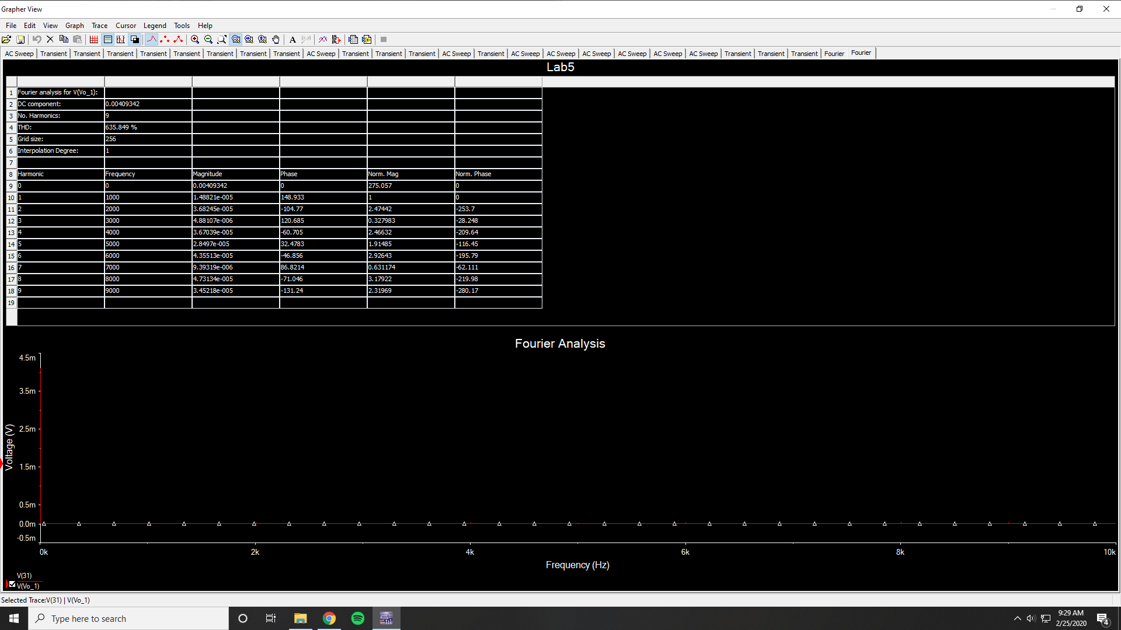

THD = 635.849 %

Slew Rate Limitations Time-Domain Simulation (75 kHz 2V)

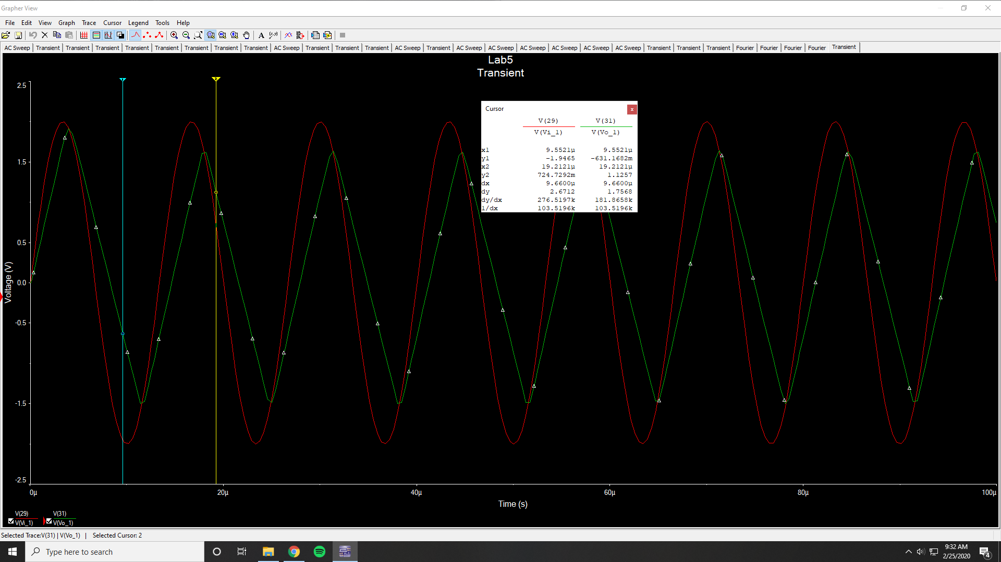

Slew Rate Limitations Fourier Simulation (75 kHz 2V)

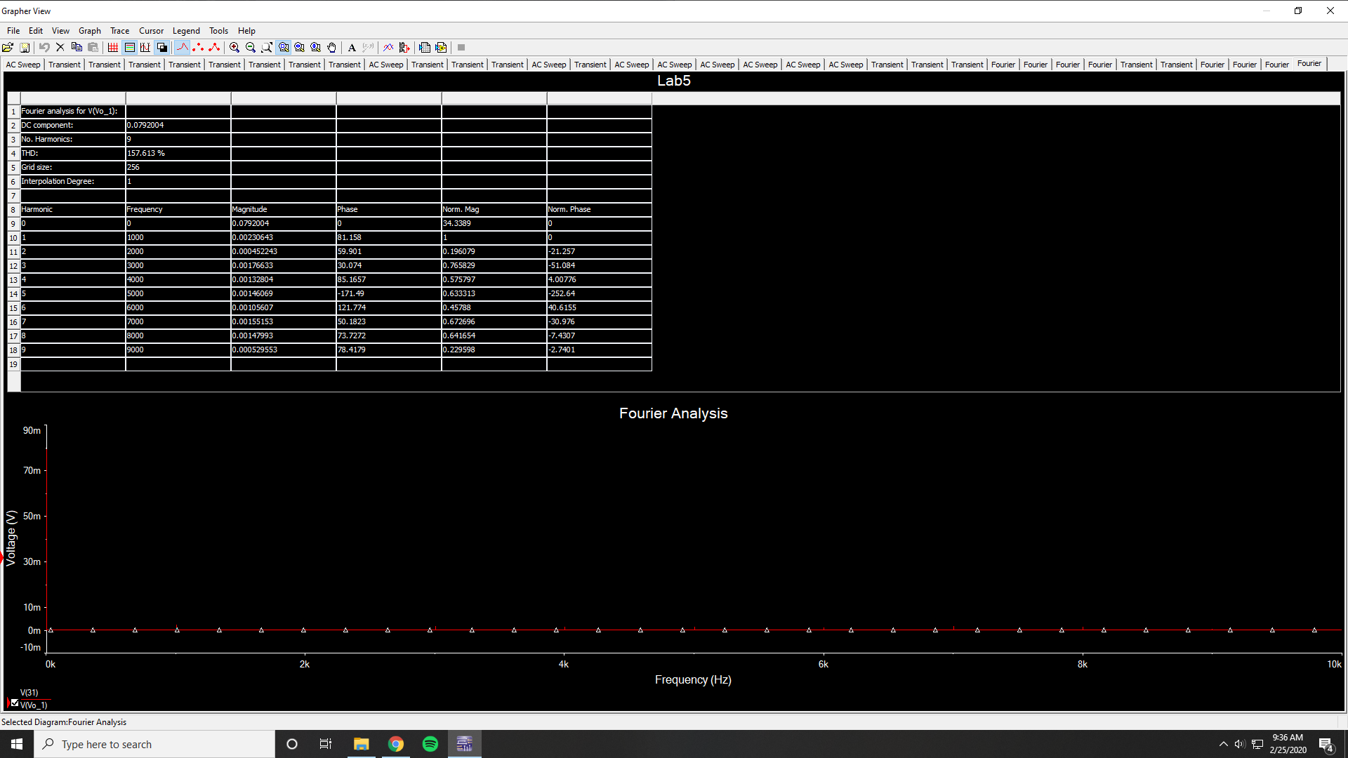

THD = 157.613 %

Slew Rate Limitations Time-Domain Simulation (150 kHz 1V)

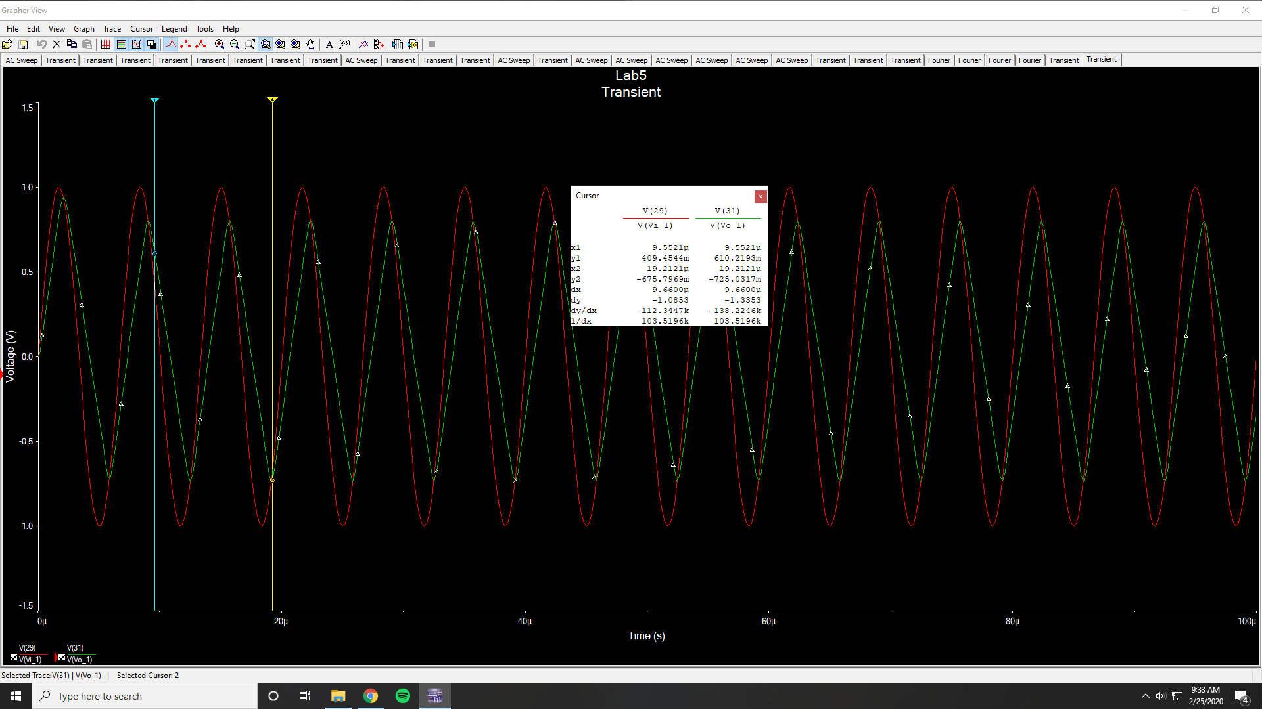

Slew Rate Limitations Fourier Simulation (150 kHz 1V)

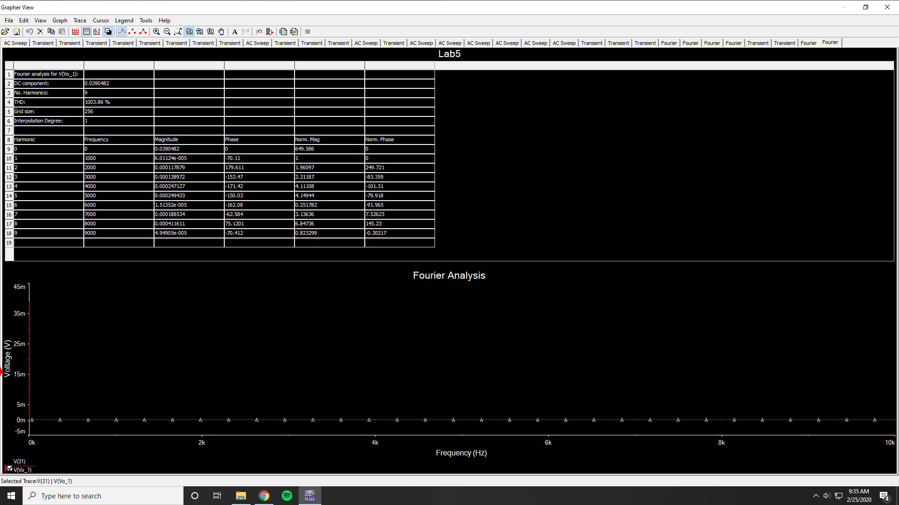

THD = 1003.86 %